Citation note:
We used ChatGPT to help debug and ask questions regarding pytorch documentation / syntax. Other citations are in the readme below and some are mentioned in the comments of the .ipynb notebook itself.

Assignment 2 practical
A reimplementation of the "small" LSTM model as described in "Recurrent Neural Network Regularization", by Zaremba et al. (2015). We add to this paper by applying the GRU model to the same data (with and without regularization)

See https://arxiv.org/abs/1409.2329

Content Overview
This project includes a Jupyter Notebook file which creates a training and testing regime for evaluating different models on the Penn Tree Bank dataset. Specifically, we test the “small” LSTM model architecture with and without dropout regularization, as well as the GRU RNN with and without regularization

Dependencies
All dependencies are imported within the markdown file. Simply run the file to import the correct packages. Please use Python 3.10+

Data Upload
We decided to use “wget” so that we can retrieve the dataset easily whenever we run the notebook. After importing the dataset, we build a vocabulary – or a mapping of each word in the data to a unique integer index. We convert each data portion (training, validation, test) to tensors of word indices before they are fed into the models.

Key Functions and Classes

'LSTMModel'
The 'LSTMModel' nn.module class defines a LSTM Recurrent Neural Network. This includes functionality for initializing the parameters, dropout (optional), embeddings, a decoder linear layer, a method to initialize the weights of the model and a forward function to allow forward pass of data through the model. Finally, the LSTMModel nn.module includes a function that initializes the hidden states and cell states for the LSTM.

'GRUModel'
The 'GRUModel' nn.module class defines a GRU Recurrent Neural Network. This includes functionality for initializing the parameters, dropout (optional), embeddings, a decoder linear layer, a method to initialize the weights of the model and a forward function to allow forward pass of data through the model. Finally, the GRUModel nn.module includes a function that initializes the hidden state. This class is very similar to the LSTMModel, with only small differences.

'evaluate'
The 'evaluate' function evaluates the performance of a model. It uses model.eval() to set evaluation mode. Then, the model initializes the loss to zero and calculates loss (using the loss function used for the 'criterion' argument) of the model on data. The function ultimately adds total loss for each chunk the model sees and returns the average loss across all the chunks of data

'train'
This function simply trains a RNN model using a specified optimizer and loss function. The train function also employs a gradient clipping technique to avoid exploding gradients. This function returns the average loss across all chunks of data for the given iteration of training.

'plot_perplexities'
The 'plot_perplexities' function is used to plot the train and test word-level perplexities as a function of training epoch. This function is called once within 'train_and_evaluate' function in order to plot these values at the end of the model training.

'train_and_evaluate'
The 'train_and_evaluate' function combines training and evaluation for an RNN model (agnostic to GRU vs LSTM). This function does so across multiple epochs and allows specification for learning rate, epoch to begin learning rate decay, final epoch, and so on. Note – learning rate is decreased by a factor of 2 (halved) at each epoch once activated (once designated epoch is reached). This function also saves model weights to a specified argument path, calls plot_perplexities, and returns the final perplexities on the train, validation, and test sets.

How to Train and Test a mode;
In order to run our cells for training and evaluating model performance at different settings, it is required that all importing and data processing cells are run and the ‘train’ and ‘evaluate’ functions are defined. We also define parameters in a cell that needs to be run in order for models to be instantiated. Finally, ‘train_and_evaluate’ should be defined in order to allow iterative training with adjustable epochs and output evaluation metrics.

To run a model, we run the following code (LSTM with no dropout) as an example:

DROPOUT = 0
LR = 3
DECAY_EPOCH = 7
MAX_EPOCH = 13

model = LSTMModel(VOCAB_SIZE, RNN_SIZE, LAYERS, DROPOUT).to(device)
optimizer = optim.SGD(model.parameters(), lr=LR)
criterion = nn.CrossEntropyLoss()

train_perplexity_lstm, val_perplexity_lstm, test_perplexity_lstm = train_and_evaluate(
model, train_data, valid_data, test_data, optimizer, criterion,
SEQ_LENGTH, MAX_EPOCH, DECAY_EPOCH, "lstm_model.pth", "LSTM (With Dropout = " + str(DROPOUT) + ") Perplexities vs Epoch"
)

print(f"Final Train Perplexity: {train_perplexity_lstm:.4f}")
print(f"Final Test Perplexity: {test_perplexity_lstm:.4f}")
print(f"Final Validation Perplexity: {val_perplexity_lstm:.4f}")

Here, we instantiate the model with our parameters (some are initialized prior, such as LAYERS, RNN_SIZE, VOCAB_SIZE, SEQ_LENGTH). Next, we select an optimizer and criterion for a loss function. Finally, we run ‘train_and_evaluate’ and collect the final perplexities for performance metrics. Note – MAX_EPOCH is the final epoch, or number of training iterations that we run a model through. DECAY_EPOCH is the epoch at which we begin learning rate decay by a factor of 2 (halving). Setting MAX_EPOCH equal to DECAY_EPOCH will effectively nullify learning rate decay.

Note, there are instructions within the Notebook for how to grab the saved weights from a model that was trained and infer with that trained model. These are under the heading “OPTIONAL: Infer With Trained Model (example)”

Results

LSTM (No Regularization)
PARAMETERS
Dropout = 0.00
Learning Rate = 3
Learning Rate Decay Epoch = 7
Number of Epochs = 13

Final Train Perplexity: 65.6332
Final Test Perplexity: 117.4962
Final Validation Perplexity: 120.1541

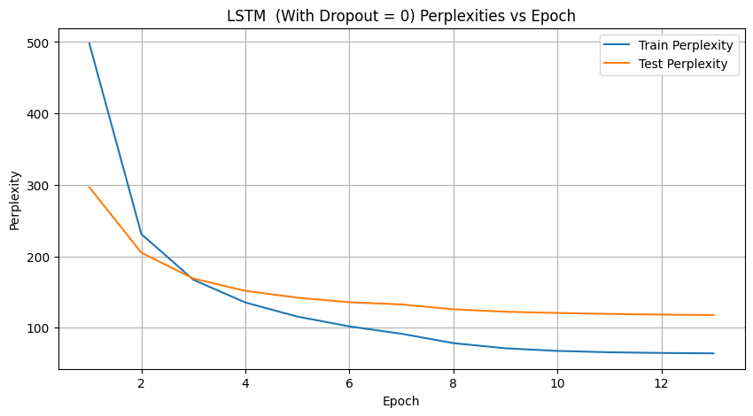

LSTM Dropout Regularization
PARAMETERS
Dropout = 0.33
Learning Rate = 6
Learning Rate Decay Epoch = 20
Number of Epochs = 30

Final Train Perplexity: 71.3923
Final Test Perplexity: 93.1329
Final Validation Perplexity: 96.6946

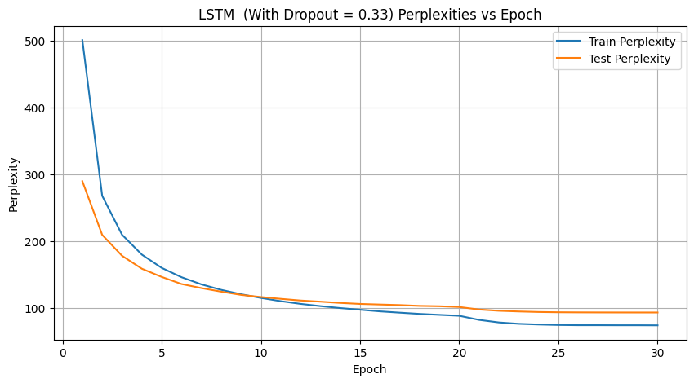

GRU (No Regularization)
PARAMETERS
Dropout = 0.00
Learning Rate = 1
Learning Rate Decay Epoch = 7
Number of Epochs = 13

Final Train Perplexity: 73.4147
Final Test Perplexity: 118.0094
Final Validation Perplexity: 122.1770

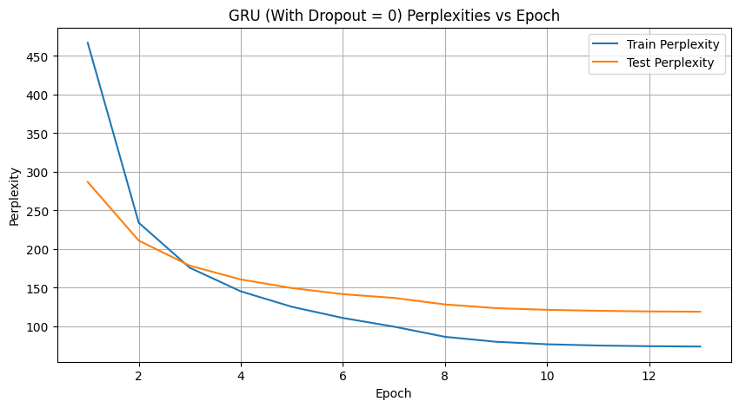

GRU Dropout Regularization
PARAMETERS
Dropout = 0.30
Learning Rate = 2
Learning Rate Decay Epoch = 7
Number of Epochs = 13

Final Train Perplexity: 60.9409
Final Test Perplexity: 98.5551
Final Validation Perplexity: 102.1842
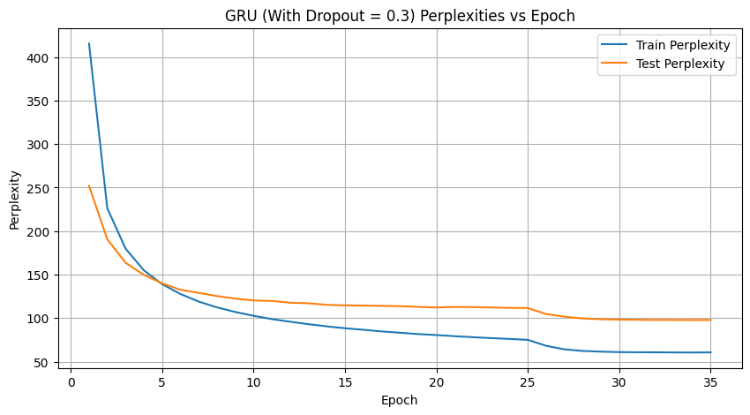

Final Results

